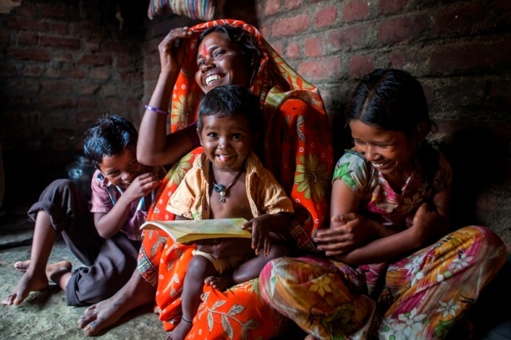

An Innovative Blueprint For Protecting Children Of Seasonal Migrant Labour
(UNICEF and SAMPARK)

Introduction
FACTOIDS
WHAT: The movement of families including children, from their village to the sugarcane belt for a temporary period in search of work (harvesting sugarcane)
WHO: Landless labourers, poorest of the poor, usually from VJNT/SC/ST/OBC, Adivasis (indigenous peoples), Banjaras (nomadic tribals)
WHEN: October to May, every year
NUMBER: 4 lakh people (Source: Bokil Milind, A Policy & Program Agenda for the Rights of Migrant Children in Maharashtra, ARC-CACL-UNICEF, February 2010)
DESTINATION: 6 districts (Ahmadnagar, Pune, Satara, Solapur, Sangli, Kolhapur)
SOURCE: 8 districts (Jalna, Beed, Latur, Nanded, Yavatmal, Wardha, Hingoli, Parbhani)
CHILDREN IMPACTED: Over 2 lakh (Source: Bokil Milind, A Policy & Program Agenda for the Rights of Migrant Children in Maharashtra, ARC-CACL-UNICEF, February 2010)
UNICEF is innovating solutions with the Department of Women and Child Development and the District Administration in two districts of Maharashtra: Jalna and Solapur to address the exclusion and vulnerability of migrants’ children.
While all families leaving their homestead and migrating are vulnerable, those migrating with their children are far more vulnerable than others. This is because the locations where they migrate are outside their home district or state. Living conditions are makeshift, services of health, education, food security, recreation are virtually non-existent and families are at the mercy of labour contractors.
This innovation is set in:
- Partur block of Jalna that sees outgoing migration, i.e. families migrating to Solapur to work at sugarcane cutting units and sugar factories.
- Six factory sites in Solapur that sees incoming migration, i.e. families come from neighbouring districts of Marathawada and Vidarbha Region of Maharashtra to work as Sugarcane cutters

Findings of a Baseline Survey in Jalna
From a baseline survey of 6355 households of 45 gram panchayats in Partur, Bhokardan and Ambad blocks of Jalna district that have a very high incidence of seasonal migration, it was found that:
- 1271 out of 6355 families, that is 20% families migrate seasonally each year
- This year 1298 out of 2518 children were to migrate with their families (52% of all children in those Gram Panchayats)
- Parents of 950 children of 6 to 14 years have respected their children’s desire to continue residing in their villages and attend school, pursue their education.

Background: Profiling a Migrants’ Family
- Families compelled to migrate are those of landless labourers belonging to the Scheduled Castes (SC) and Scheduled Tribes (ST) - families facing social, economic exclusion in their own villages, with low economic assets and limited livelihood options.
- Their migration commences at the close of the festive season of Diwali (October) and they return in April or May the following year.
- Parents are unwilling to part with their children who are in the 0-7 age so they take them along no matter how poor the circumstances at the migration destination site.
- Children in the 9-14 years age group support families to care for younger siblings.
- Older children in the 14-18 years age group often accompany their parents as additional hands to bring in a higher income or to look after infants and younger siblings.
Interventions
The goal is two-fold of making migration safe for children of migrants and to ensure their access to services like protection, healthcare and education among others at the source and destination. For children willing to stay back in their villages the provision of safe and secure community-based alternative care.
FACTOIDS
3 CATEGORIES OF CHILDREN
- 0 to 7 year age group: left in the care of older siblings in the factory camps or fields with the parents
- 9-14 years age group: left alone to in camp to attend to all chores and to take care of younger siblings
- 14-17 years age group: working alongside parents to bring in a higher income

WHY MIGRATION IS UNSAFE FOR CHILDREN
- Living arrangements make-shift
- Lack of access to healthcare and Anganwadi centres for nutrition
- Children miss out on school, do chores or work in farms instead
- No safe spaces to play

Underlying Principles of the Innovation
  - The innovation has an age-specific focus as children of different ages have different needs.
0-6 years
7-14 years
15-18 years

  - The highest-level of convergence is established at the village-level between the Gram Panchayat, Village Child Protection Committee (VCPC), School Management Committee (SMC) and functionaries like School teachers, Anganwadi Workers and ASHAs. The policy framework for convergence is mandated by the CEO of the District Administration (Jalna) and the Principal Secretary DWCD.
Convergence is directed at putting support infrastructure in place; including social protection, healthcare and education services at both locations: source and destination.
The role of the NGO was to build linkages, support functionaries in playing their roles and facilitate social mobilization.
  - Solutions involved children’s participation, alternative care for children was family and community based and designed to address the specific needs and context of each child.

- Innovations at the Source District

- Setting up of Migration desk at GP-level
- Registration of all migrant families
- Maintaining records of all children who are migrating with their parents and those staying back in the village
- Developing care plans and linkage to service including alternative care arrangements for children staying behind
- Family-level: 538 children in kinship care with elders and relatives
- Village-level: 09 children in the care unrelated family with close support from the Gram Panchayat and VCPC.
- Migration Kit: A migration kit for older children (15-18 year olds) migrating for work. It contains important information like the rights of children and helpline numbers for emergencies.

- Linking Children to Education and Health Services
- SMC and VCPCs ensured attendance of children in schools and participation in an after-school study and recreation class
- ASHAs and Anganwadi Workers provide care and monitor the health and nutrition of children who stay through fortnightly check-ups and quarterly health camps.

- Support programmes: Camps and classes facilitated by trained youth members of VCPC are supported by local NGO at the village-level. The VCPC youth act as mentors for children providing recreation, over-seeing school attendance, conducting support study classes, monitoring food, clothing, shelter and emotional well -being. Telephone contacts with parents facilitated once every 15 days and as needed.

- Innovations at the Destination District.

- Migrant resource centre at the GP/ward-level (once families arrive)
- Registers families coming in.
- links families to services like temporary ICDS, crèches

- Education and Protection Services
- Enrolls children in local schools and arranges for transportation with the help of school authorities and factory management.
- Undertakes Support education and recreation classes for children by Bal Mitras of VCPC
- Facilitating admission of children to residential schools or children’s homes for the duration of the family’s stay in the destination district, in case of extreme vulnerability and when the family’s housing situation is tenuous.

- Health facilities for primary healthcare by ASHA and AWW

The coordination and convergence at the destination points covering approximately 3528 children spread across 6 Sugar factories and farms linked with the factories is led by the Divisional Commissioner of the WCD, Pune for Solapur District in Pune division with engagement of District Collector.

